**TIME SERIES DATA LOADING AND PROGRAMING TECHNIQUES**

**AIM:** Implement programs for time series data cleaning, loading and handling times series data and pre-processing techniques.

**Procedure:**

from google.colab import drive

drive.mount('/content/drive')

import pandas as pd

import matplotlib.pyplot as plt

import seaborn as sns

df = pd.read_csv('/content/drive/MyDrive/TimeSereisDatasets/daily-website-visitors.csv')

df.head(10)

df.tail(10)

| **Row** | **Day** | **Day.Of.Week** | **Date** | **Page.Loads** | **Unique.Visits** | **First.Time.Visits** | **Returning.Visits** |
| --- | --- | --- | --- | --- | --- | --- | --- |
| **2157** | 2158 | Monday | 2 | 8/10/2020 | 3,638 | 2,745 | 2,325 | 420 |
| **2158** | 2159 | Tuesday | 3 | 8/11/2020 | 3,740 | 2,742 | 2,258 | 484 |
| **2159** | 2160 | Wednesday | 4 | 8/12/2020 | 3,767 | 2,904 | 2,477 | 427 |
| **2160** | 2161 | Thursday | 5 | 8/13/2020 | 3,621 | 2,780 | 2,322 | 458 |
| **2161** | 2162 | Friday | 6 | 8/14/2020 | 2,971 | 2,308 | 1,922 | 386 |
| **2162** | 2163 | Saturday | 7 | 8/15/2020 | 2,221 | 1,696 | 1,373 | 323 |
| **2163** | 2164 | Sunday | 1 | 8/16/2020 | 2,724 | 2,037 | 1,686 | 351 |
| **2164** | 2165 | Monday | 2 | 8/17/2020 | 3,456 | 2,638 | 2,181 | 457 |
| **2165** | 2166 | Tuesday | 3 | 8/18/2020 | 3,581 | 2,683 | 2,184 | 499 |
| **2166** | 2167 | Wednesday | 4 | 8/19/2020 | 2,064 | 1,564 | 1,297 | 267 |

df.shape

df.info()

data_null = df.notnull().sum

df['Page.Loads'] = df['Page.Loads'].str.replace(',', '').astype(int)

daywise_data = df.groupby('Day')['Page.Loads'].sum()

daywise_data.plot(kind='bar', figsize=(8, 5), color='purple')

plt.title('Page Loads by Day of the Week')

plt.xlabel('Day of the Week')

plt.ylabel('Page Loads')

plt.xticks(rotation=45)

plt.show()

data = df.drop_duplicates()

print(f"Dataset now has {data.shape[0]} rows and {data.shape[1]} columns.")

df.plot(figsize=(14,7))

df = df.dropna()

df.shape

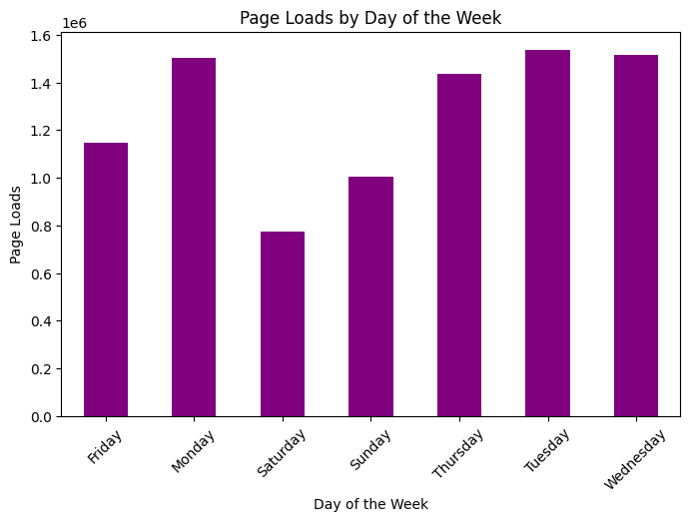

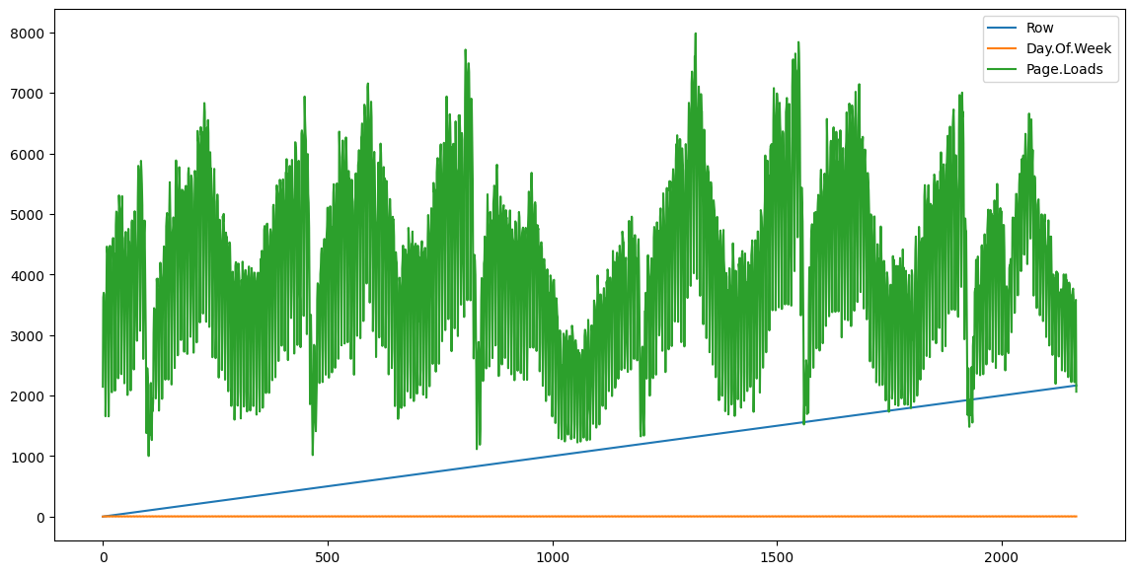

**RESULT:**

Thus the program has been excecuted successfully.